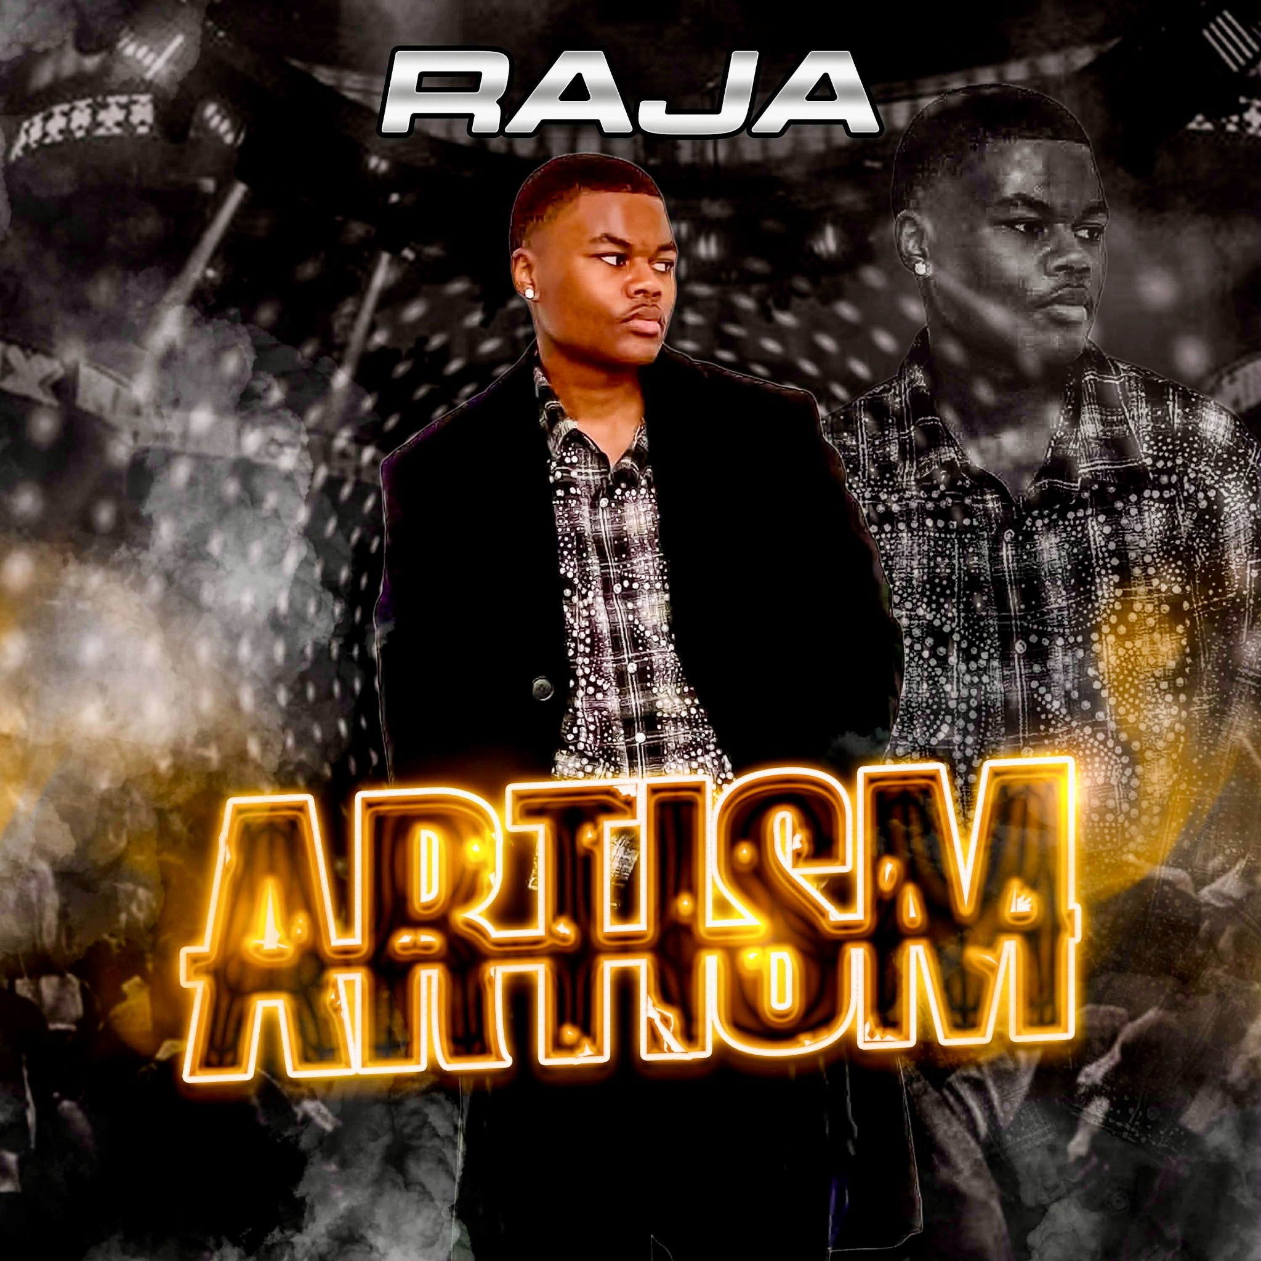

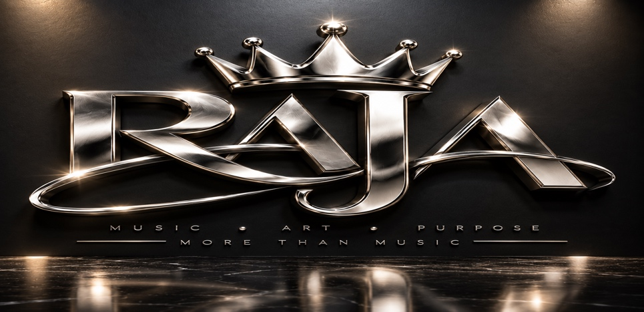

Next Generation R&B; Star | Atlanta

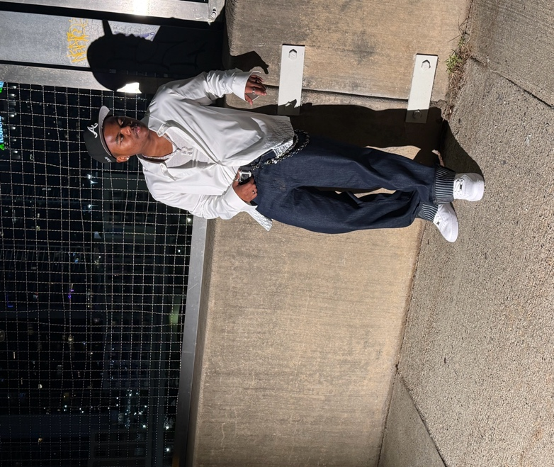

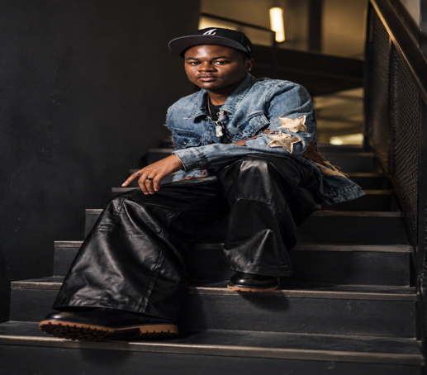

Artist Bio
RAJA is an 18-year-old R&B; artist from Atlanta, Georgia, redefining what it means to be a young creative in today’s music landscape. Currently a senior at Utopian High School of the Arts. Raja is a singer, songwriter, and dancer, RAJA blends soulful vocals with modern production to create emotionally driven records. Diagnosed with ADHD at age 6 and autism spectrum disorder at age 9, RAJA has faced challenges that shaped his artistry. Despite obstacles, he continues to push forward, turning his journey into powerful music. He wrote his first song “Better” at age 14 and in more recently “Dance in the Rain” charted at #12. Raja collaborated with super producer K Major and released two new singles “Dip” and “Roll the Dice” which are both creating a buzz.
Raja is a member of The Atlanta Music Project a non-profit organization that provides world class music training and performance opportunities. The AMP Senior Youth Choir was named a winner in the 2024 World Choir Games in New Zealand.
Raja is also a member of The Spark Club at Usher’s New Look started by R & B Icon Usher Raymond. A program that provides access, training and innovation in entertainment to inner city youth.

WHY RAJA
RAJA represents the next wave of R&B; —authentic, emotionally driven, and culturally relevant. His story fuels a powerful narrative that connects deeply with Gen Z audiences.
Opportunity:
- Early-stage artist with strong brand identity
- High emotional connection with audience
- Scalable across music, film, and live performances
- Raja’s music blends contemporary R&B with emotion, personality, and a sound that can continue to grow with the right team behind him.
- With the right production, marketing, promotion, touring opportunities, and strategic partnerships, RAJA has the potential to grow into a recognizable artist and brand with long-term value.

Featured Music

“Dance In the Rain”
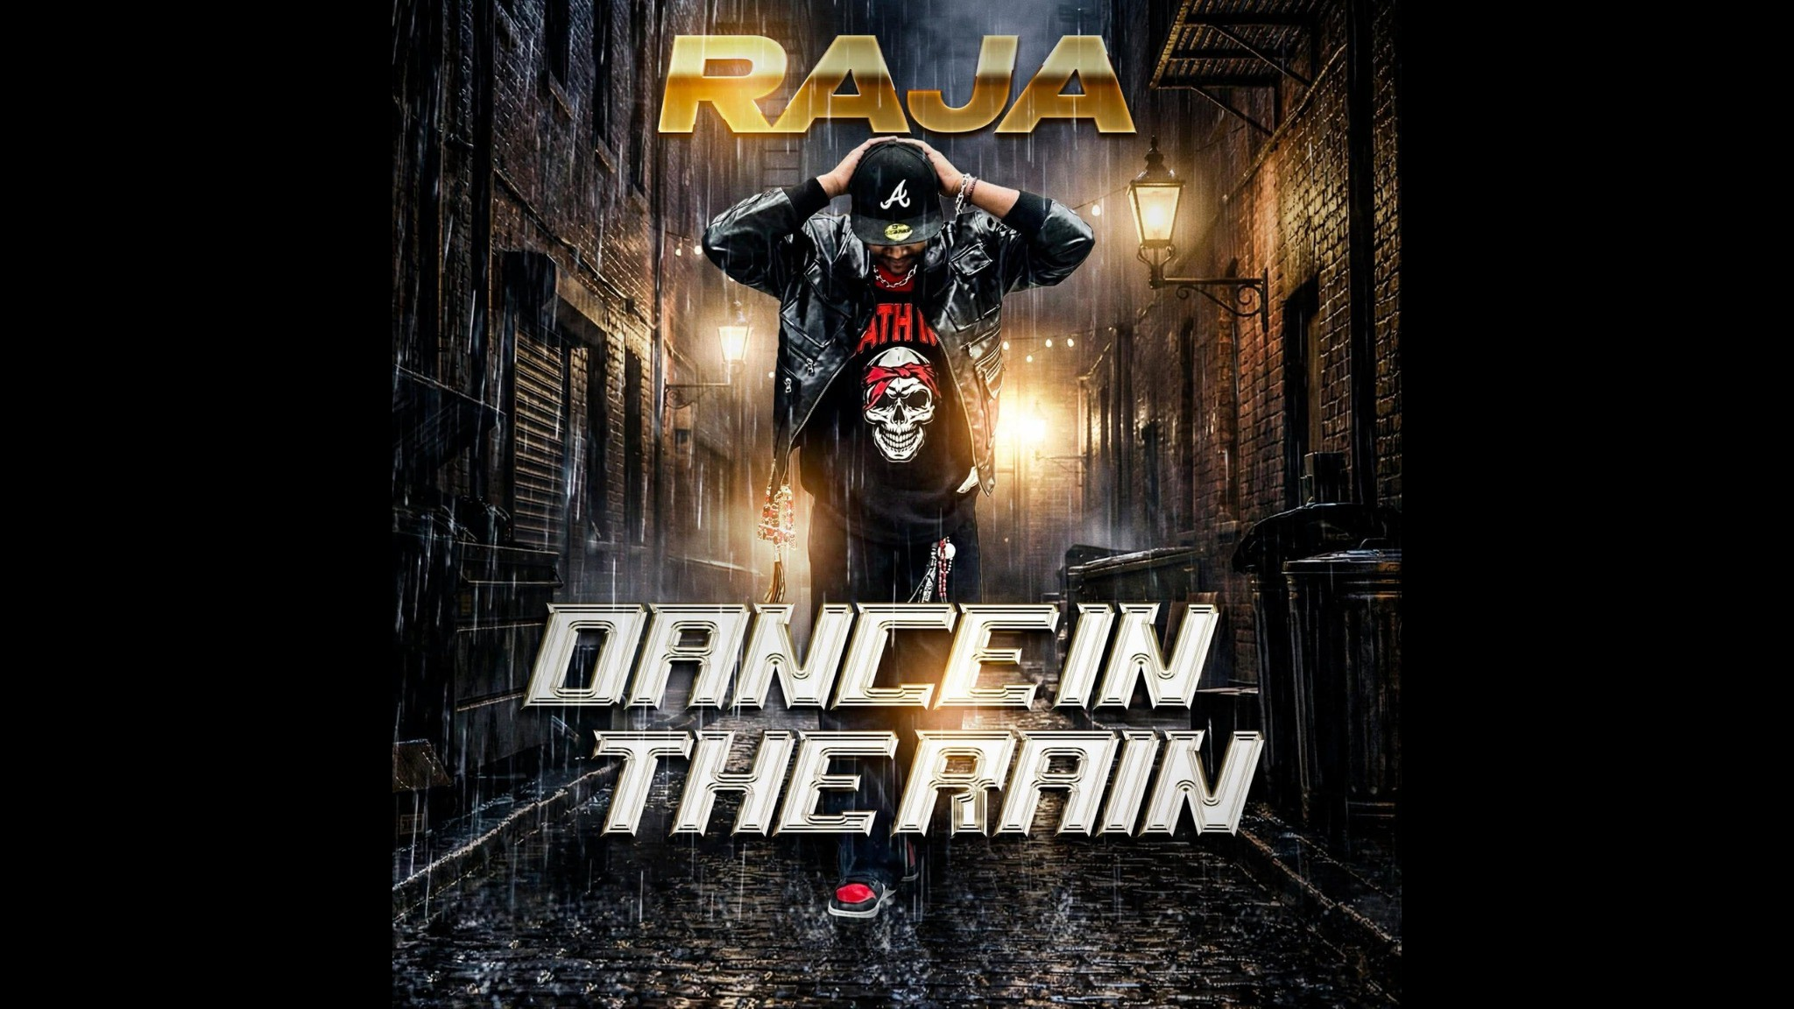

Listen Now

“DIP”
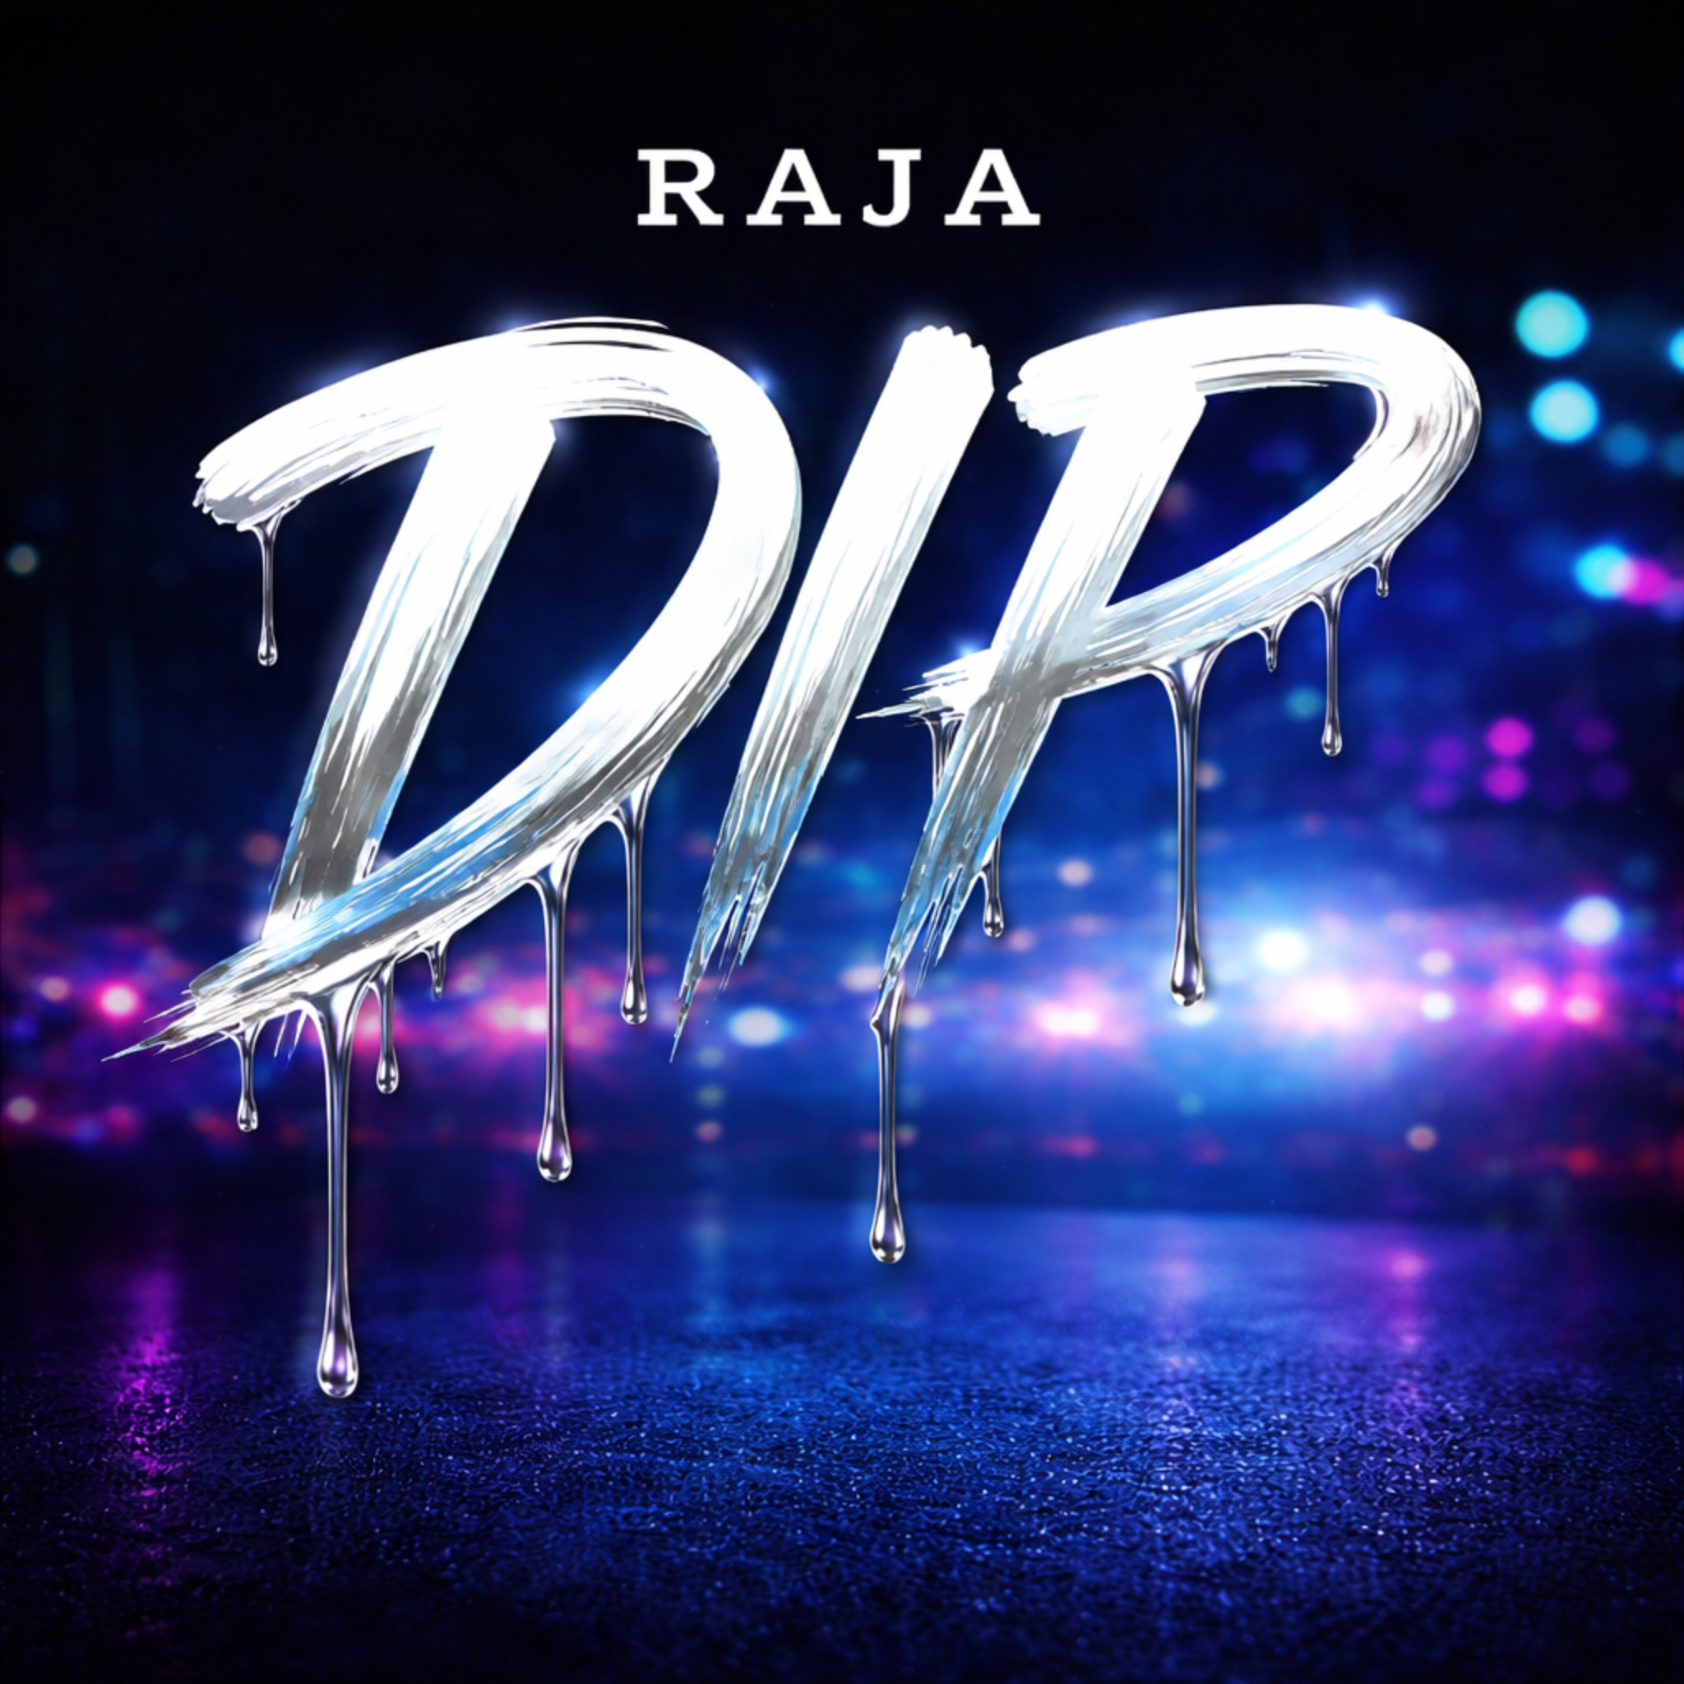
Listen Now

“STAY”

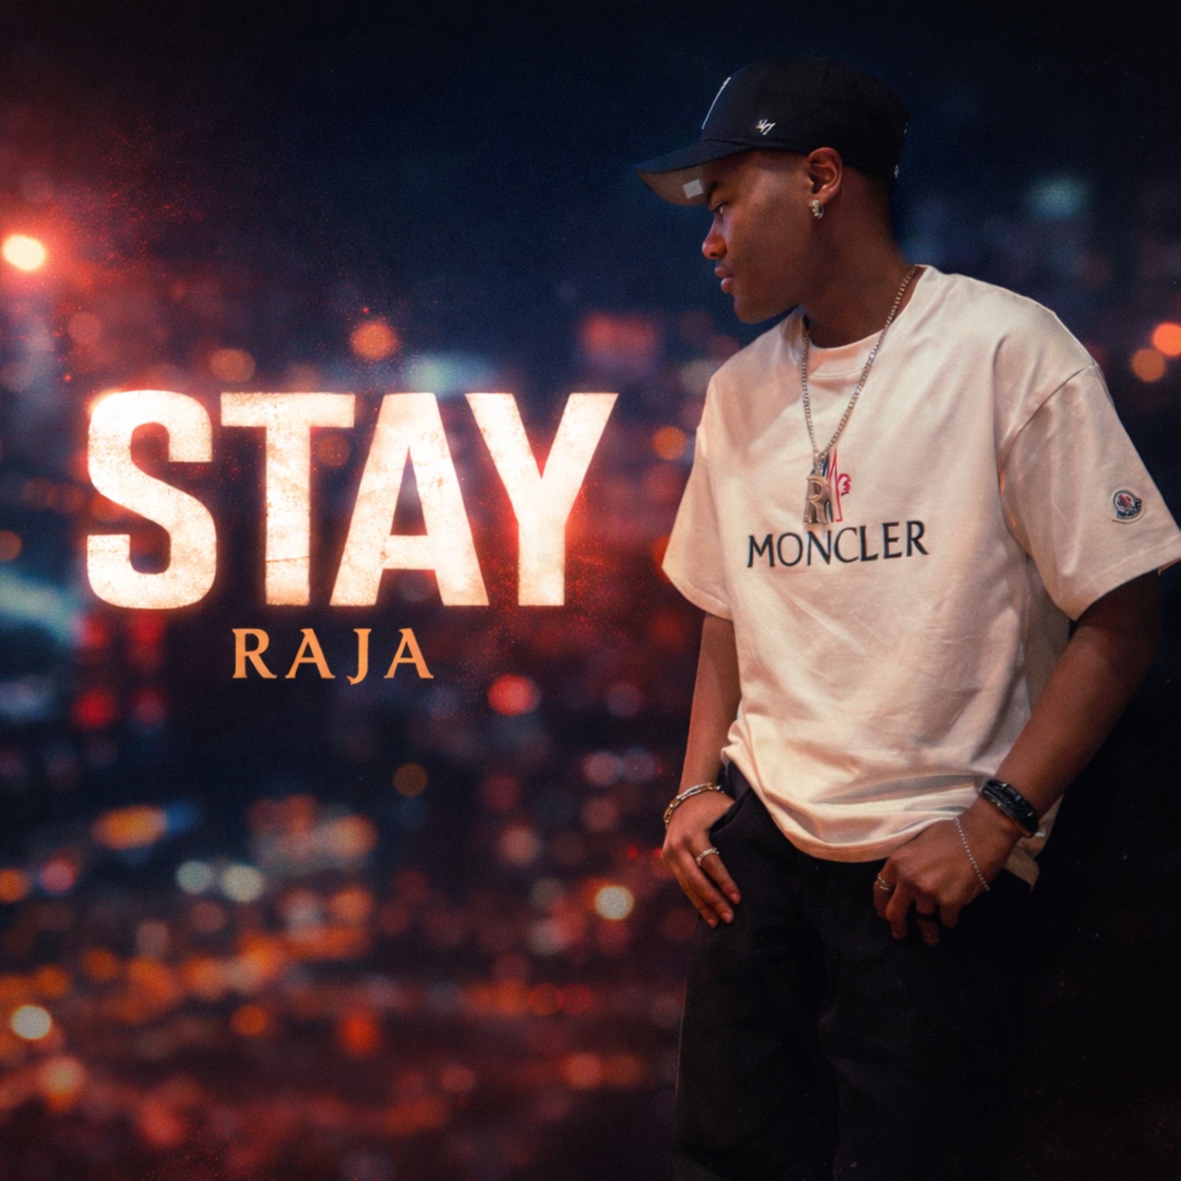
Listen Now

“ROLL THE DICE”
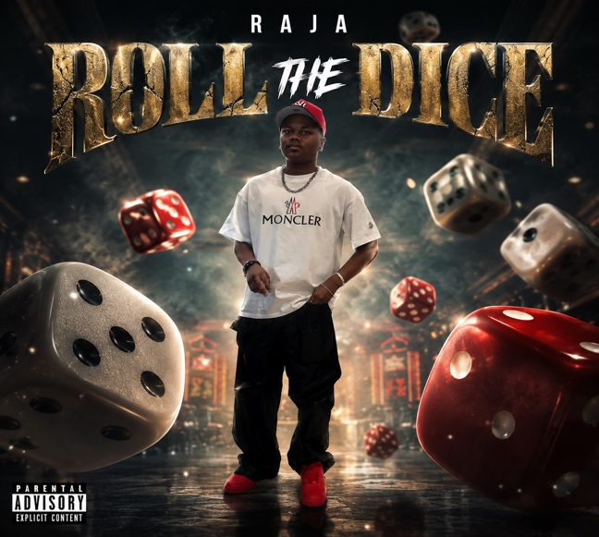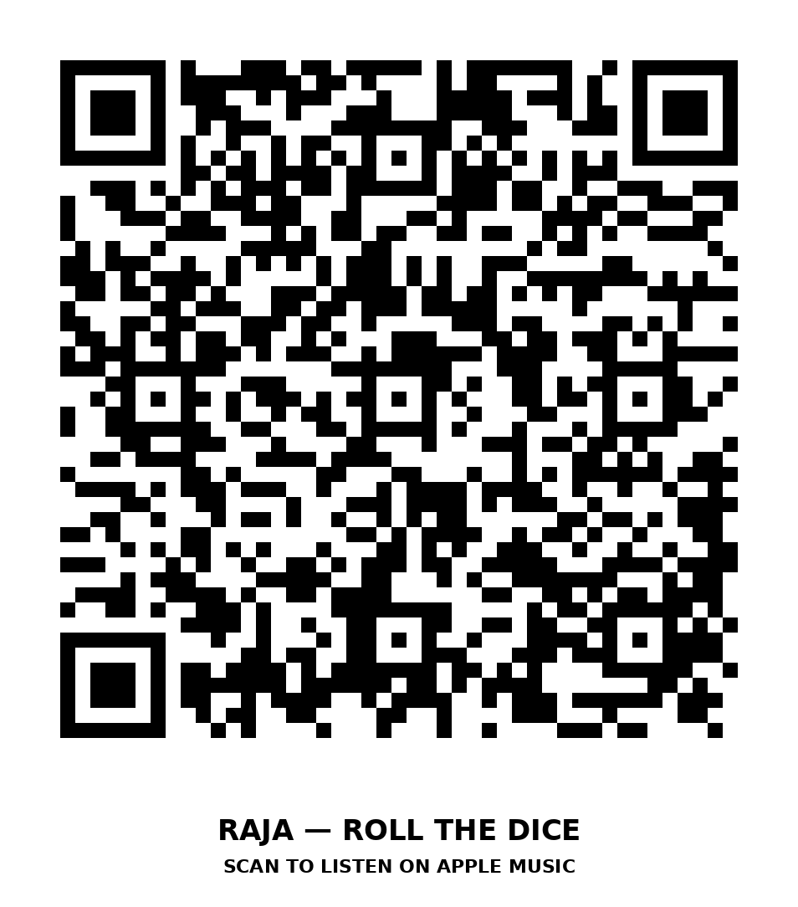

https://youtu.be/VQrAp4y_0Ek?si=7pejB4GisCWEgqbC



Booking: elignentertainment@gmail.com

YouTube: rajathe_artist

Vevo: rajaofficialvevo

Instagram: @iamrajathe_artist

TikTok: @iamrajathe_artist

